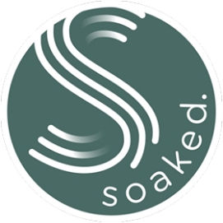
Soaked. Ordering Form 2020

Soaked. Kangaroo Island
ABN 91 794 271 703
Soaked.ki@gmail.com
Date:_________________________ 0430411487
Name: _______________________________________
Contact number: _____________________________
Email: ___________________________________________________________________
Deliver to: _______________________________________________________________

Item | Quantity | Unit Price* | Total Price
Happiness Bomb |  | $9
Lavender Bomb |  | $9
Postage |  | TBC

*Orders of more than 12 bath bombs will be priced at $8 each.

Email completed form to soaked.ki@gmail.com

Once the price has been finalised with postage costs, Soaked. will email the provided email address with the ordering form with the finalised amount. Please send the finalised amount to the account listed below with your name as the reference.

Every effort will be made to use the highest quality ingredients, however COVID-19 has created some challenges and consequently substitutes may have to be used temporarily.

ACCOUNT NAME: Soaked. BSB 065004 ACCOUNT NUMBER 1106 0551

